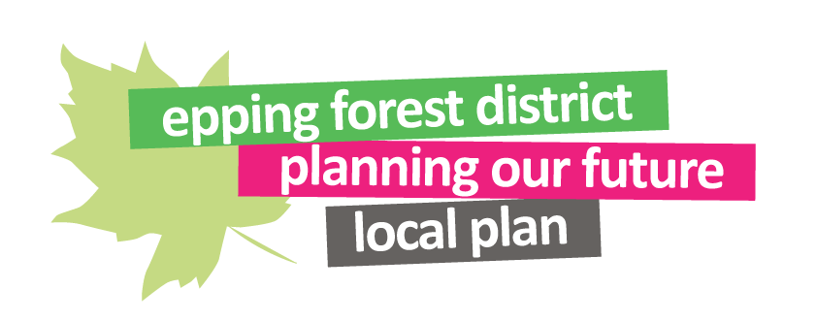
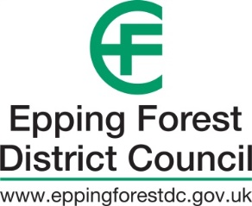

Representation form: Consultation on the Main Modifications to the emerging Local Plan

This form should be used to make representations on the Main Modifications to the Epping Forest District Local Plan Submission Version 2017 to the Local Plan Inspector. The Main Modifications Schedule, online response form and all required supporting documentation can be accessed via the Examination website at www.efdclocalplan.org. Please complete and return representations by Thursday 23rd September 2021 at 5pm.
Please note, the content of your representation including your name will be published online and included in public reports and documents.

It is important that you refer to the guidance notes on the Examination website before completing this form.

The quickest and easiest way to make representations is via the online response form at www.efdclocalplan.org.

If you need to use this downloadable version of the form please email any representations to MMCons@eppingforestdc.gov.uk

Or post to: MM Consultation 2021, Planning Policy, Epping Forest District Council, Civic Offices, 323 High Street, Epping, Essex, CM16 4BZ

By 5pm on Thursday 23rd September 2021

This form is in two parts:
Part A – Your Details
Part B – Your representation(s) on the Main Modifications and/or supporting documents. Please fill in a separate Part B for each representation you wish to make.

The Main Modifications Schedule and supporting documents to the Main Modifications can be accessed online at www.efdclocaplan.org. The supporting documents to the Main Modifications are listed below. Representations concerning their content will be accepted to the extent that they are relevant to inform your comments on the Main Modifications. However, you should avoid lengthy comments on the evidence/background documents themselves.

- Council’s response to Actions outlined in Inspector’s post examination hearing advice (Examination document reference number ED98), July 2021 (ED133)
- Sustainability Appraisal Report Addendum, June 2021 (June 2021) (ED128/ EB210)
- 2021 Habitats Regulations Assessment, June 2021 (ED129A-B/EB211A-B)
- Epping Forest Interim Air Pollution Mitigation Strategy, December 2020 (ED126/ EB212)
- EFDC response to Inspector’s Post Hearing Action 5 and supplementary questions of 16 June 2021, July 2021 (ED127)
- Epping Forest District Council Green Infrastructure Strategy (ED124A-G/ EB159A-G)
- Harlow and Gilston Garden Town Latton Priory Access Strategy Assessment Report, July 2020 (ED121A-C/EB1420A-C)
- Revised Appendix 2 to the Epping Forest District Council Open Space Strategy (EB703), July 2021 (ED125/EB703A)
- IDP: Part B Infrastructure Delivery Schedule 2020 Update (ED117/EB1118)
- EFDC Consolidated and Updated Viability Evidence 2020 (ED116/ EB1117) Consolidated
- Statement of Common Ground Addendum East of Harlow, September 2020 (ED122A-B)
- South Epping Masterplan Area Capacity Analysis (Sites EPP.R1 and EPP.R2), March 2020 (ED120/ EB1421)
- In addition to the above there are a number of Examination Documents, which include Homework Notes produced by the Council as a result of actions identified by the Inspector at the hearing sessions as well correspondence between the Council and the Inspector following hearings. These Examination Documents can all be accessed on the Local Plan website.

Please only attach documents essential to support your representation. You do not need to attach representations you have made at previous stages.

Part A – Your Details
1. Are you making this representation as? (Please tick as appropriate)

a) Resident or Member of the General Public or

b) Statutory Consultee, Local Authority or Town and Parish Council or

c) Landowner or

d) Agent

Other organisation (please specify)

3. Agent’s Details (if applicable)
2. Personal Details

Title

First Name

Last Name

Job Title

(where relevant)

Organisation
(where relevant)

Address Line 1

Line 2

Line 3

Line 4

Post Code

Telephone

Number

E-mail Address

Part B – Your representation on the Main Modifications and/or supporting documents

If you wish to make more than one representation, please complete a separate Part B form for each representation

4. Which Main Modification number and/or supporting document does your representation relate to? (Each Main Modification within the Schedule has a reference number. This can be found in the first column i.e. MM1, MM2 and each Supporting Document has a reference number beginning with ED).

Any representation on a supporting document should clearly state (in question 6) which paragraphs of the document it relates to and, as far as possible, your comments should be linked to specific Main Modifications. You should avoid lengthy comments on the supporting documents themselves.

MM no. Supporting document reference

5. Do you consider this Main Modification and/or supporting document:
(Please refer to the Guidance notes for an explanation of terms)

- Is Legally compliant Yes No

- Sound Yes No

If no, then which of the soundness test(s) does it fail

Positively prepared Effective

Justified Consistent with national policy

6. Please give details of why you consider the Main Modification and/or supporting document is not legally compliant or is unsound. Please be as precise as possible. If you wish to support the legal compliance, soundness of the Local Plan or compliance with the duty to co-operate, please also use this box to set out your comments.

(Continue on a separate sheet if necessary)

7. Please set out what change(s) you consider necessary to make the Main Modification and/or supporting document legally compliant or sound, having regard to the test you have identified in the question above (Positively prepared/Justified/Effective/Consistent with national policy) where this relates to soundness. You will need to say why this change will make the Submission Version of the Local Plan legally compliant or sound. It will be helpful if you are able to put forward your suggested revised wording of any policy or text. Please be as precise as possible.

Please note your representation should cover succinctly all the information, evidence and supporting information necessary to support/justify the representation and the suggested change, as there will not normally be a subsequent opportunity to make further representations based on the original representation at publication stage.
After this stage, further submissions will be only at the request of the Inspector, based on the matters and issues he/she identifies for examination.
(Continue on a separate sheet if necessary)

8. Have you attached any documents with this representation which specifically relate to an MM or supporting document?

Yes No

Signature: Date

